Book | Date Read | Fun Facts We Learned
PB&K Hooray! by Janet Nolan

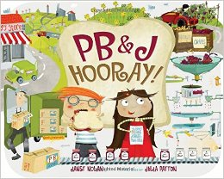

Senses on the Farm by Shelley Rotner

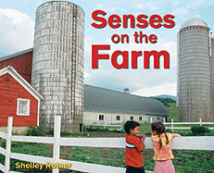

Tyler Makes Pancakes! By Tyler Florence
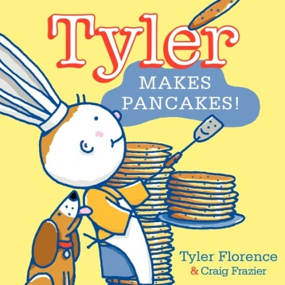

The Beeman by Laure Krebs

