Book | Date Read | Fun Facts We Learned
First Peas to the Table by Susan Grigsby
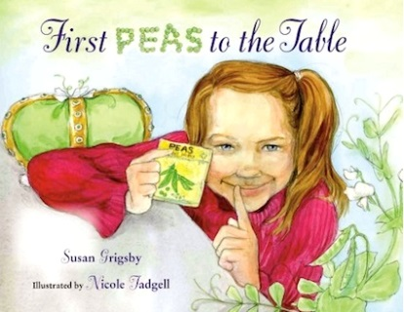

Apple Orchard Riddle by Margaret McNamara

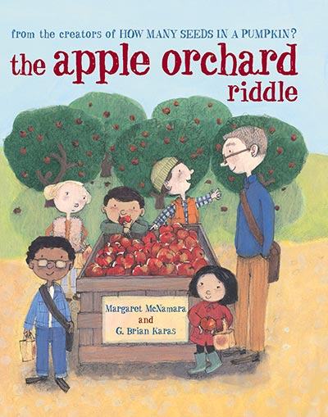

Farmer George Plants a Nation by Peggy Thomas
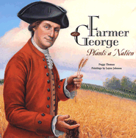

In the Garden with Dr. Carver by Susan Grigsby
