We Teach My American Farm
Detailed Outline for Facilitators: 1 Hour Event

Materials:
Item | Status | Received?
Food service gloves (1 per teacher)
Cotton balls (5 per teacher)
Seeds (5 per teacher)
Yarn/Ribbon (24” per teacher)
Hole Punches (1/10 teachers)
Spray bottles (1/10 teachers)
“We Teach My American Farm” PowerPoint | Provided
Projector, screen, presenter laptop, and internet connection | Provided by host site/ facilitator
Promotional Resources: Letter to teachers, suggested email content, social media tips, promo flyer | Provided
Photo release (1 per teacher) | Please email to participants, or have hard copy on hand for participants to complete on site.

Prior to the Event:
- Review the outline and PowerPoint.
- Download the My American Farm offline kiosk program here: http://myamericanfarm.org/download/kiosk
  - Note: If your computer does not automatically install it, you will need to install Adobe Air to run this program. https://get.adobe.com/air/
- Cut ribbon/yarn into 2’ sections, 1 section per participant

On Site Set-up at the Event:
- Secure wi-fi log in information for room and post for participants to see.
- Open presentation PowerPoint, as well as a web browser window showing www.myamericanfarm.org.
- Set up a lab materials table containing the following: seeds, cotton balls, gloves, ribbon, spray bottles with water, hole punches

Time | Learning Activities | Facilitator Reflections: What worked? How did/would you modify?
As Participants Enter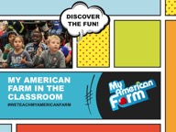 | Welcome and collect/complete photo release forms.  (SLIDE 1)
15 Min  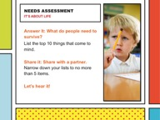  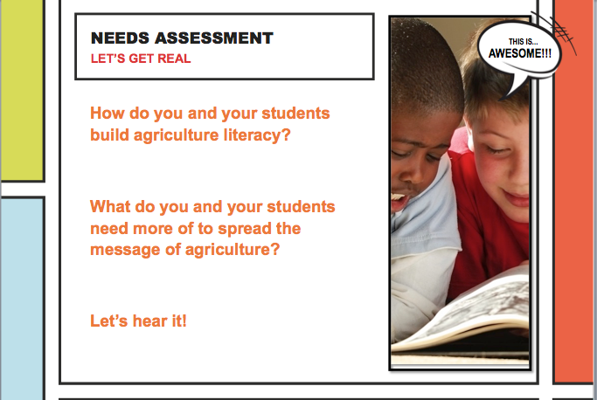  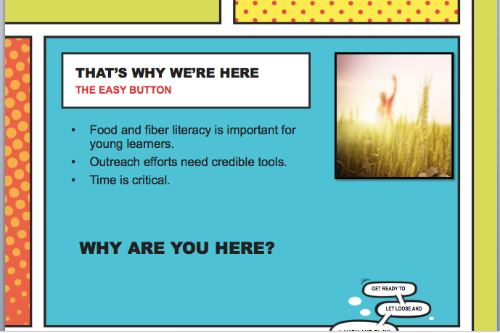  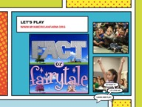 | Key Concept: Agricultural literacy is important and can make your job easier!  - Needs Assessment (SLIDE 2)  - Engagement: Ask participants to individually generate a list of the top 10 things people need to survive.  - In pairs, have participants share and narrow lists down to 3-5 items.  - Ask participants to share, capturing responses on a white board or tear sheet. Listen for items that relate to food, fiber and shelter.  - Engagement: Ask participants to consider the following: (SLIDE 3)  - How do you and your students build agriculture literacy?  - What do your schools need more of to share the message of agriculture?  - Capture responses on a white board or tear sheet. Listen for examples related to time, standards-based resources, or real-life experiences for students.  - Set context for the need for agricultural literacy on an elementary level. (SLIDE 4)  - Agriculture is our most vital industry. Agriculture encompasses all of the industries and processes involved in the production and delivery of food, fiber and fuel that humans need to survive and thrive.  - Food and fiber literacy at a young age can make your job easier!  - Outreach events are valuable opportunities for your students to share what you’ve taught them, but they need credible tools to help them teach content.  - Compiling a presentation is a lot less daunting and time-consuming when the resources have already been created.  - Engagement: Provide teachers an opportunity to make a personal connection and share their motivation for attending.  - Ask teachers to respond to the following questions:  - What motivated you to attend this workshop?  - What is one thing you hope to take away from this experience?  - Application: Teachers play a short version of “Fact or Fairytale” (SLIDE 5)  - Remind teachers that the purpose of this event is to equip them with great free resources to make their job easier while having fun. And it all starts with the joy of playing games!  - Pull up “Fact or Fairytale” on My American Farm. Inform teachers that you are going to play a quick game to show them how easy it can be to integrate My American Farm in the classroom.  - What it sounds like: Let’s see how easy it is to use My American Farm in the classroom, by meeting my friend Jacob. We’ll help Jacob out just like you might help Jacob with your students. Jacob can’t decide if what he hears is fact (true) or fairytale (untrue). When you hear a statement, give a big thumbs up if you think it is fact. Cross your arms and make a loud buzzer sound if you think the statement is fairytale. Let’s play!  - Play a few rounds eliciting teacher responses and selecting the choice most teachers indicated.
10 Min  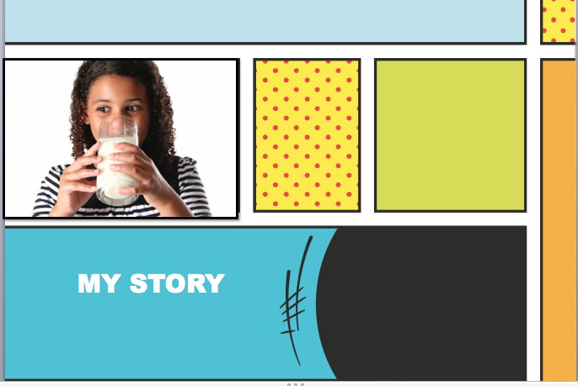  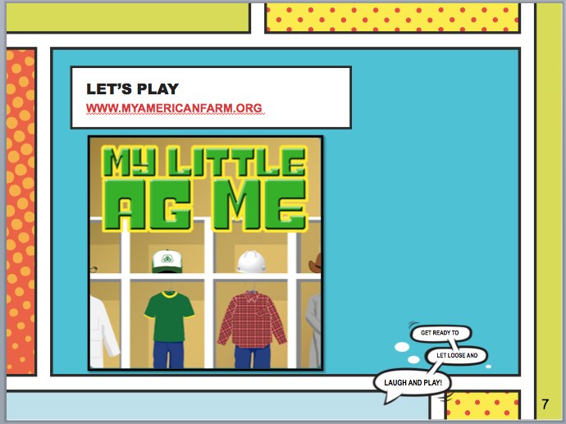 | Key Concept: Sharing you’re My American Farm story  - Provide teachers with your personal testimony with using My American Farm. Include additional slides with pictures and information about the test pilot experience. (SLIDE 6)  - Assure teachers that them and their students can confidently engage elementary students in the discovery of food, fiber and natural resources.  - Application: Teachers play “My Little Ag Me” (SLIDE 7)  - Introducer teachers to the game “My Little Ag Me” on My American Farm. Inform participants that this is a game for young learners, with the goal of exposing them to the variety of careers in agriculture.  - Have participants play in pairs or small groups on their personal computers. If internet connection is an issue, play as a large group by bringing up volunteers to complete rounds.  *Feel free to play a different game if there is one that really resonated with your pilot students from your story.
20 Min  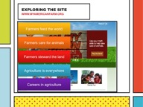  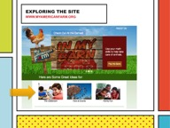  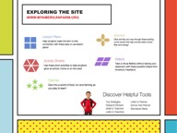  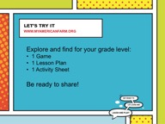  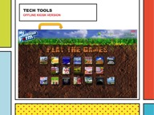  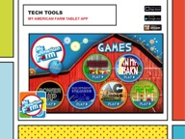  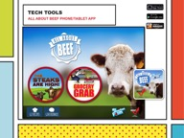 | Key Concept: Exploring the site and resources!  Setup: Use a projector and screen connected to the main computer to introduce participants to the layout of My American Farm and key resources available. Participants may follow along on their personal laptops.  - What is it?  - My American Farm is a free educational learning platform featuring more than 20 learning games and hundreds of free classroom resources. The site a special project of the American Farm Bureau Foundation for Agriculture, made possible by title sponsor DuPont Pioneer.  - What are the underlying messages? (SLIDE 8)  - All resources communicate one or more of the following key messages:  - Farmers feed the world  - Farmers care for animals  - Farmers steward the land  - Agriculture is everywhere  - Careers in agriculture  - How is the site organized? (SLIDE 9-10)  - The home page speaks to our key audiences, and gives you a chance to jump directly to the games. Click “Check out All The Games” in the top section of the page to preview the games section.  - From the home page, select “The Classroom”. Here’s what you’ll find:  - Lesson Plans: These are instructor-led guides. Search by subject area and/or age. Each lesson plan gives you the option to incorporate a specific My American Farm game. All lessons are aligned to national learning standards. *Note: We are in the process of re-aligning some resources that were developed before Next Generation Science Standards launched.  - Activity Sheets: These are student-driven stand-alone resources. Search by subject area and/or age.  - Games: You can also get to the games from this page. Print a Passport to Sustainability for students to track game completions! Students can print their certificate at the end of a completed game and glue in their passport. As an alternate option, teachers can stamp or sign off on passport game completions.  - eComics: These fun student readers are available as PDF downloads and in online eReader format. Feel free to print and use in your classroom.  - Videos: These videos from the popular TV series America’s Heartland support key messages and topics found in the games.  - Helpful tools: Find suggested strategies, class-sets of passport stickers, and a standards-matrix to review all resource alignment to national learning standards.  - Application (SLIDE 11): Give teachers approximately 5 minutes to individually find a lesson, activity sheet, and game for their respective grade. Have teachers share one resource they discovered and how they might use this in the classroom. You may wish to have teachers share in pairs, small groups, or as a whole.  - Tech Tools  - Using the “kiosk” offline version (SLIDE 12): Show teachers that they can download their own offline version of My American Farm games by clicking “Play Offline” from the games page. The offline version contains all of the games. (Updated each January with new games from the previous year.)  - This is a great classroom tip, because the kiosk program can be added to classroom computers without having students online.  - Demonstrate using the kiosk program you have downloaded if available.  - There are two apps available for My American Farm:  - My American Farm App (SLIDE 13): Featuring 6 My American Farm games for tablet only. Great if you have a class set of tablets! Available for iPad, Android and Kindle Fire.  - All About Beef App (SLIDE 14): (COMING SOON!) Featuring 2 beef related games for tablet and smartphone. Available for iPhone, iPad, Android devices and Kindle Fire.
10 min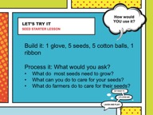 | Key Concept: Agriculture is hands-on!  - Invite teachers to build their own “Garden in a Glove” activity, which is found on My American Farm under Classrooms>Lesson Plans, under the title “Seed Starter”. Each teacher is to (SLIDE 15):  - Pick up one food service glove, five cotton balls, five seeds, and a piece of ribbon/yarn.  - Place one cotton ball and one seed in each finger of the glove.  - Use a spray bottle to slightly moisten cotton balls.  - Use a hole-punch to punch two holes in the top of the glove. (You may wish to do this ahead of time, or share hole punches.)  - String ribbon/yarn through the top of the glove to slightly close the glove and create a hook from which they can hang their glove in a sunny area.  - Walk teachers through a series of processing questions you might use in a classroom:  - What do most seeds need to grow? Listen for water, sunlight, and a growing medium. Growing medium is typically soil, but in this case we are using a cotton ball!  - What can you do to take good care of your seed? Listen for carefully paying attention to the seed, watering as needed, placing in a warm, sunny area, etc.  - What do farmers do to care for their seeds? Listen for similar responses – giving the seeds the right amount of water and nutrients, caring for the soil, etc.  - Ask teachers to identify how they might use this activity in their classrooms and share.
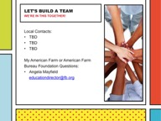  5 min  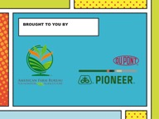  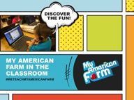 | Key Concept: We’re here for you, let’s build a team!  - Reference the items generated at the start of the workshop with regard to what teachers wanted to know about agriculture, or learn from this process. Let teachers know that organizations like Farm Bureau and Agriculture in the Classroom are here to help support their efforts to connect young people to the source of their food, fiber and natural resource.  - Communicate ways to stay connected (SLIDE 16):  - Include local contacts as appropriate.  - For questions related to My American Farm, email educationdirector@fb.org.  - Express thanks for title sponsor DuPont Pioneer making this special project of the American Farm Bureau Foundation for Agriculture possible! (SLIDE 17)  - Remind teachers that agriculture is a fun, relevant way to support the key concepts students are expected to learn in the classroom. Challenge teachers to consider creating an agricultural literacy team at their school! Thank teachers for their participation and encourage them to stay connected! (SLIDE 18)

