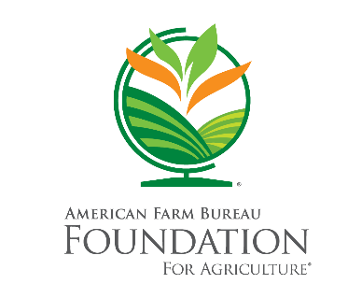
Name: County, State:
Submit a photo or Word document of your completed scavenger hunt to educationdirector@fb.org for a chance to win a book of the year bundle!
- Visit the My American Farm website and play the game “Equipment Engineer.” What piece of machinery do you build in the forestry jobs’ challenge? http://www.myamericanfarm.org/games/equipment-engineer
___________________________________________________________
- Check out the My Little Ag Me Books & Video Educator’s Guide. Which of the suggested activities would you use to teach kids about agriculture virtually? https://www.agfoundation.org/ag-lit-catalog/view/suggested-activities-for-my-little-ag-me-books-career-challenge-videos
___________________________________________________________
- One of the Feeding Minds Press books is “Tales of the Dairy Godmother.” The main character, Chuck, is based on a dairy farmer. Watch the video “Chuck the Ice Cream Farmer.” How does Chuck relate feeding cows corn back to an audience of kids? https://www.youtube.com/watch?v=iCOVsq4WrXg
___________________________________________________________
- The Spring 2021 Purple Plow Challenge is the “H2 Grow Challenge.” As part of the challenge, students construct a model of a system that ingrates waste from aquatic animals to benefit plants by providing nutrients. What are 2 of the needs that this system must address? https://www.purpleplow.org/challenges/h2grow-challenge
___________________________________________________________
- List 3 free resources available to you through the Ag Lit Catalog. https://www.agfoundation.org/ag-lit-catalog
___________________________________________________________
- You can find the Food and Farm Facts Jeopardy available as a free download through our Ag Lit Catalog. What is the correct answer for “Modern Farmers for $800”? https://www.agfoundation.org/ag-lit-catalog/view/food-and-farm-facts-jeopardy
___________________________________________________________
- What is an example of one of our “At-Home Learning Activities” that we didn’t share during today’s workshop? https://www.agfoundation.org/at-home-learning
___________________________________________________________
- The answers to Kids’ Questions About Agriculture are posted on agfoundation.org and on The Foundation’s Facebook page. If you haven’t already, visit our Facebook page and “like” it so you can stay updated on our newest resources. What is the most recent Kids’ Question About Agriculture that we’ve answered?
___________________________________________________________

