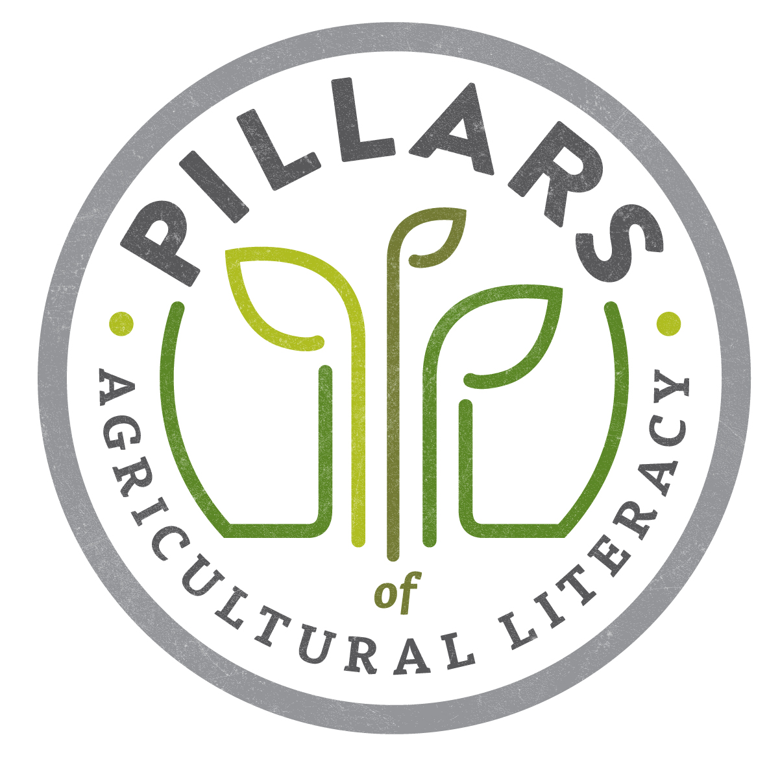
Ag Literacy Planning – Review Worksheet

Pillars of Ag Literacy
Directions: Catalog all of your recent ag literacy efforts and complete the review of each.
Activity or Material | When Presented/ Developed  - How frequently?  - When first developed/conducted? | Results  - Evidence of impact? | Relationship to Pillars of Ag Literacy  - Foundational Knowledge  - Ag and the Environment  - Ag and Food, Fiber & Energy  - Ag and Animals  - Ag and Lifestyle  - Ag and Technology  - Ag and The Economy | Target Audience  - Pre-K-Kindergarten  - 1st-3rd Grade  - 4th-6th Grade  - Middle School/Junior High  - High School  - College Students  - Young adults  - Older adults | Method of Engagement  - Classroom presentations  -Retail location events  -Fairs/festival booths  -Farm tours and other hosted special events  -Social media  -Developing new materials (brochures) to share  -Getting books and materials into libraries, classrooms and other locations
Example: Ag books for school library | Once a year, past 5 years | The librarian appreciates the books | Foundational Knowledge | K-6 | Sharing materials

