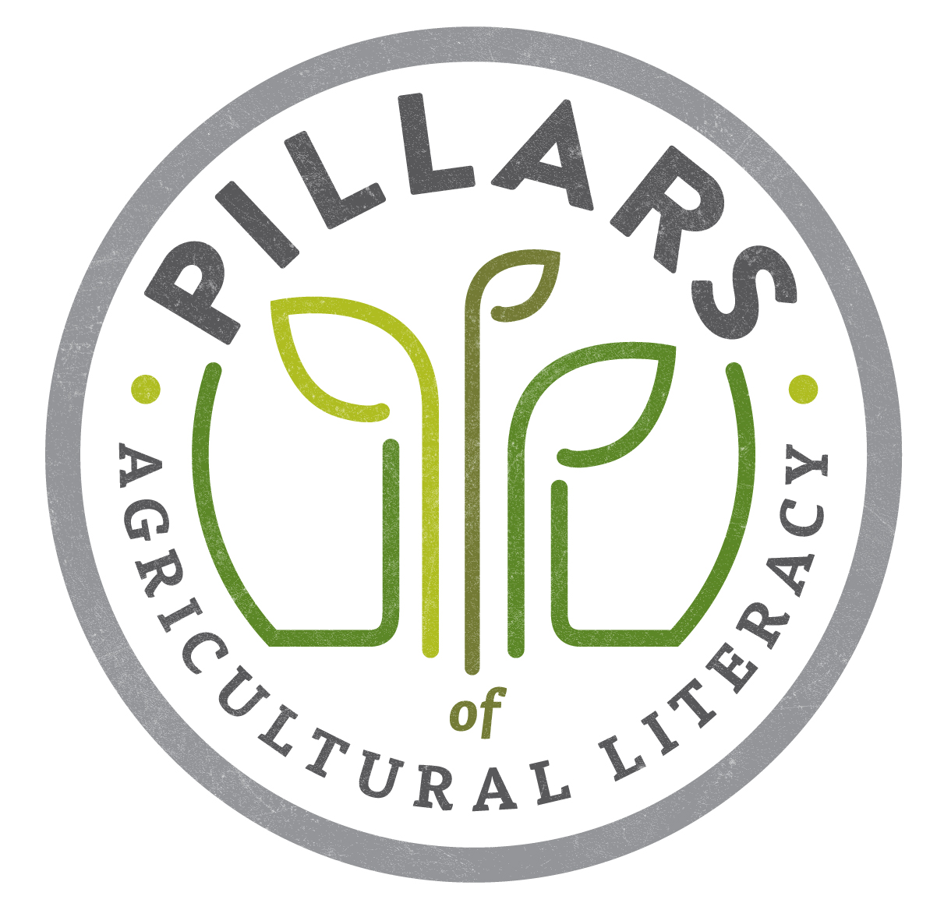
Ag Literacy Planning – Strategic Planning Worksheet

Pillars of Ag Literacy
Directions: Catalog all of your recent ag literacy efforts and complete the review of each.
Objective  - What is the goal? | Relationship to Pillars of Ag Literacy  - Foundational Knowledge  - Ag and the Environment  - Ag and Food, Fiber & Energy  - Ag and Animals  - Ag and Lifestyle  - Ag and Technology  - Ag and The Economy | Activity or Material  - Describe the activity and/or material to develop and the method of engagement | Target Audience  - Pre-K-Kindergarten  - 1st-3rd Grade  - 4th-6th Grade  - Middle School/Junior High  - High School  - College Students  - Young adults  - Older adults | Plan – timeline, budget and people  - When?  - $$ needed?  - Leaders/planners?  - Volunteers needed?
Example: Increase acceptance of technology used in agriculture. | Ag and Technology | Host on-farm activities for teachers and students. One-day “job shadow” for teachers & field trips for students and parents where they leave with materials to take home and read | 5th and 6th grade teachers, students and their parents | Start summer of 2015 with teacher job shadows & student/parent field trips in spring of 2016  $$ - TBD  Led by YFR committee  Need 10-15 volunteers

