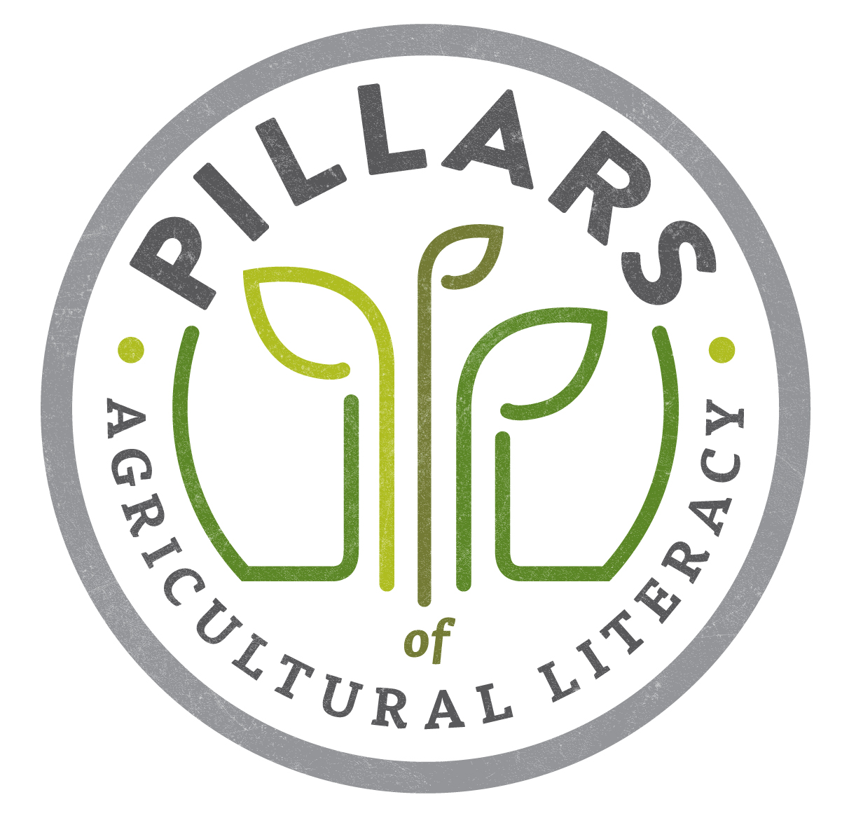
Ag Literacy Planning Survey

Have leaders and key stakeholders complete this survey to begin the agricultural literacy planning process using the Pillars.

Pillars of Ag Literacy
Directions: Review the Pillars of Ag Literacy. Consider the issues and challenges facing agriculture in your area/community. Rank the seven components (1 through 7) with #1 being the most important to you and the where ag literacy efforts should be focused.
_____ Foundational Understanding of Agriculture
_____ The relationship between Agriculture and the Environment
_____ The relationship between Agriculture and Food, Fiber and Energy
_____ The relationship between Agriculture and Animals
_____ The relationship between Agriculture and Lifestyle
_____ The relationship between Agriculture and Technology
_____ The relationship between Agriculture and The Economy

Target Audience
Directions: Consider the importance of reaching key audiences in your area/community. Rank the listed audiences (1 through 8) with #1 being the most important audience to reach.
_____ Pre-Kindergarten-Kindergarten
_____ 1st-3rd Grade
_____ 4th-6th Grade
_____ Middle School/Junior High
_____ High School
_____ College Students
_____ Young adults
_____ Older adults

Methods of Engagement
Directions: Consider your organization’s proficiency in each of the following methods of engaging audiences. Rank your proficiency (1 through 7) with #1 being the method of which you are most proficiency.
_____ Classroom presentations
_____ Retail location events
_____ Fairs/festival booths
_____ Farm tours and other hosted special events
_____ Social media
_____ Developing new materials (brochures) to share
_____ Getting books and materials into libraries, classrooms and other locations

